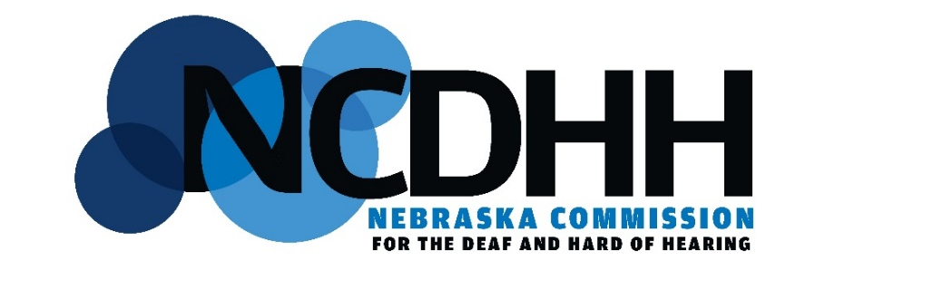
MENTAL HEALTH ADVISORY COMMITTEE MEETING

Date: Thursday, 4 June, 2026
Time: 2:00 PM – 4:00 PM CST
Location: Omaha State Office Building
1313 Farnam Street, Omaha, NE
Meeting Room E (next to NCDHH Office)
Interpreters: Ben Sparks and Sharon Sinkler
Minutes: Sakura Yodogawa-Campbell
Zoom Link:
https://us06web.zoom.us/j/82933005963?pwd=P5dz8pagH2XebzxEBsNg0V33OH0hi9.1
Meeting chat link
https://us06web.zoom.us/launch/jc/82933005963
Meeting ID: 829 3300 5963
Passcode: 032206

Agenda

- Meeting Call to Order by Chairperson

- Public Comment Period (Limit to 10 minutes total, please)

- Approval of Agenda

- Approval of Prior Meeting Minutes

- NCDHH Agency Updates
  - Interim Executive Director (Kim Davis)
  - Behavioral Health Liaison (Sakura Yodogawa-Campbell)

- New Business
  - NCDHH Staff, Vali Hitz-Events and Program Coordinator

- Committee Member Updates

- Next Meeting Date
  - 27 August 2026, Location TBA (Lincoln, NE)

