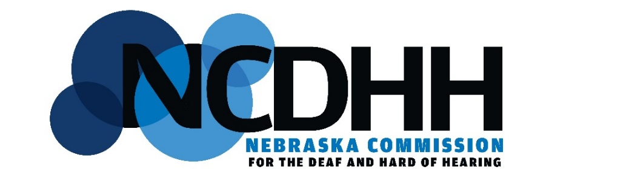
MENTAL HEALTH ADVISORY COMMITTEE MEETING
Date: 27 February 2025
Time: 2:00 – 4:00 PM
Location: Omaha OSOB Room 227,
1313 Farnam Street
Interpreters: Pamela Duncan & Deb Teller
Minutes: Gina Peterson
CART: NONE
Agenda

- Meeting Call to Order by Chairperson

- Approval of Agenda

- Approval of Prior Meeting Minutes
  - 15 February 2024
  - 15 May 2024
  - 15 August 2024
  - 14 November 2024

- Discussions
  - Purpose of MHAC and By-Laws
  - Co-Chair
  - MH (using VLOGS, social media, newsletters to get the message out)
  - Update BH resources on Agency website
  - Community Involvement and Engagement

- NCDHH Agency Updates
  - Executive Director [Management Team] Reports
  - Behavioral Health Coordinator Reports
    - 6-month probation/2024 recap
    - 2025 Enrichment Grant workshop

- Committee Member Updates

- Next Meeting Date
  - 29 May 2025 @ 2pm

