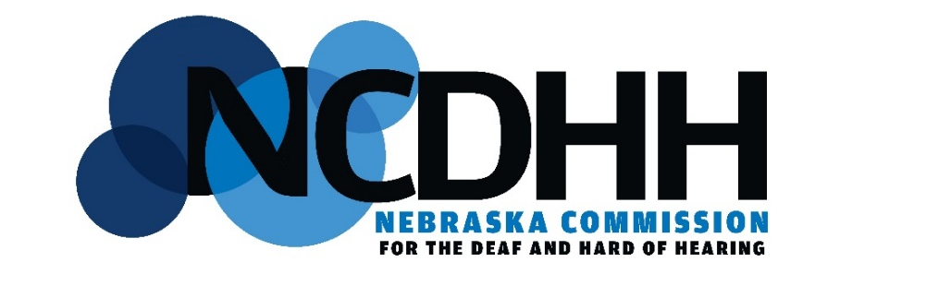
MENTAL HEALTH ADVISORY COMMITTEE MEETING

Date: Thursday, February 26, 2026
Time: 2:00 PM – 4:00 PM CST
Location: Barbara Weitz Community Engagement Center
6400 South University Dr Rd North, Room 118. Omaha
Interpreters: Meghann Cassidy and Abby Giambattista
Minutes: Sakura Yodogawa-Campbell, BHL
CART: Don Rombach (via Zoom)

Zoom Link: https://us06web.zoom.us/j/81616657466
Meeting ID: 816 1665 7466

Agenda

- Meeting Call to Order by Chairperson

- Public Comment Period (Limit to 10 minutes total, please)

- Approval of Agenda

- Approval of Prior Meeting Minutes

- NCDHH Agency Updates
  - Interim Executive Director (Kim Davis)
  - Behavioral Health Liaison (Sakura Yodogawa-Campbell)

- New Business
  - Future of MHAC

- Committee Member Updates

- Next Meeting Date
  - TBA after March Board Meeting

