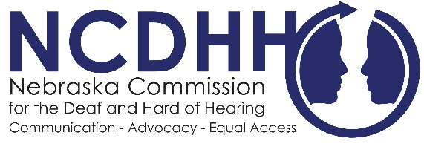
Board Member Committees
Executive Committee
The Executive Committee’s serves as the personnel committee that develops and revises personnel policies as needed for approval by the full Board. The Executive Committee also performs such duties in the management of the Commission as may be directed or delegated by the Full Commission. Members serving on this committee include the chair, vice-chair, and secretary of the Board.
Legislative Committee
The role of the Legislative Committee is to develop, monitor, and recommend changes to current NCDHH State Statute or new legislation that will benefit people who are deaf and hard of hearing people in cooperation with the various organizations serving the deaf or hard of hearing community. This committee must meet prior to the beginning of the legislative session (fall) to formulate bills and be active during the legislative session.
Interpreter Issues Committee
The role of the Interpreter Committee is to review and update interpreter best practices, sign language evaluation systems and internal procedures.
Education Committee
The role of the Education Committee is to reviews ways to educate the general public, state agencies, public entities, and people who are themselves Deaf or Hard of Hearing about the impact of hearing loss in general. Specifically, the Education Committee seeks ways to implement the vision, mission and goals of the Commission through awareness activities. In addition, the Education Committee reviews issues emanating from educational practices, rules, and legislation.
Recognition Committee
The role of the Recognition Committee is to review and recommend awards for any outstanding work by staff of the agency. The Full Board has approved an awards and recognition policy for the agency’s staff. The policy also applies to the Interpreter Review Board.

