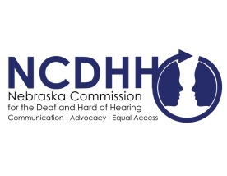
Pete Ricketts  Governor  Jeremy Fitzpatrick,  Chairperson  Commission Members  Frances Beaurivage  Lincoln  Jonathan Scherling  Omaha  Candice Arteaga  Greenwood  Dr. Stacie Ray  Lincoln  Norman Weverka  Brainard  Robert Feit  Lincoln  Sandra Shaw  Seward  Diane Schutt  Fairbury  John C. Wyvill Executive Director | LB 965 Signed Into Law  Governor Pete Ricketts has signed LB 965 into law. Sponsored by Sen. Mike McDonnell, LB 965 will require special language assessments for children who are deaf and hard of hearing. The bill also includes provisions of LB 839, sponsored by Sen. Anna Wishart, recognizing American Sign Language as an official language of Nebraska.  Equal access to education and language acquisition was designated as a priority for NCDHH by the Full Board.  “The future will be brighter for deaf and hard-of-hearing children in Nebraska as a result of LB 965,” NCDHH Board Chair, Jeremy Fitzpatrick said. “The Commission is excited about working with the Department of Education to assess and improve outcomes for deaf and hard of hearing children pursuant to the law.”  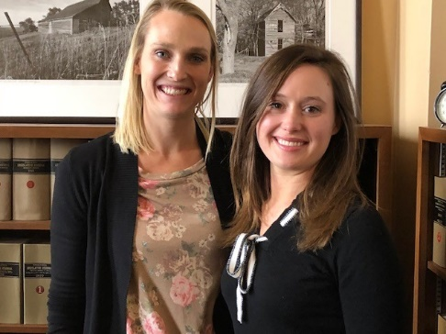  LB 965 requires the Nebraska Department of Education (NDE), in collaboration with NCDHH, to establish and coordinate a language assessment program for children who are deaf or hard of hearing. NDE and NCDHH will publish a joint annual report specific to language and literacy development milestones of children who are deaf or hard of hearing relative to their peers who are not deaf or hard of hearing.  The bill also allows NDE to provide for the teaching of American Sign Language in schools and students would obtain world language credit.  These efforts would not have been possible without the collaboration and work from multiple stakeholders and agencies, all sharing the same goal for equal education access for all.  “The Department of Education is excited to collaborate with NCDHH and others to improve outcome for our earliest investment in creating supports to build a broader, bolder, and better system for our deaf and hard of hearing infants and toddlers,” said Nebraska Commissioner of Education, Matthew Blomstedt.  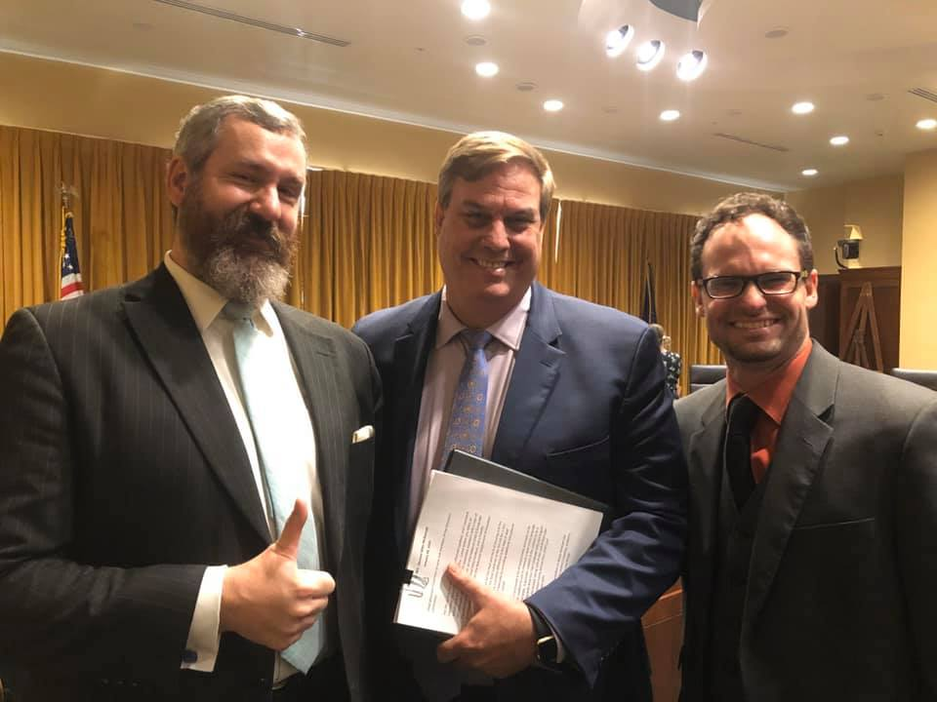  Linsay Darnall Jr., representative for the Nebraska Association of the Deaf legislative committee, stressed the importance on the future implications this bill will have. “I look forward to the day when all deaf and hard of hearing children will have an equal access to language as they rightly deserve with LB 965 so that they can serve the state of Nebraska when their time comes,” he said.  Newest NCDHH Board Member, Jonathan Scherling applauds the work it took for this legislation.  "I am thrilled to witness a key victory in the second session of the 106th Nebraska Legislature when the senators unanimously passed LB 965 to create a language assessment program for deaf children,” he said. “I want to applaud Dr. Pete Seiler and his committee in taking the initiative to help make this happen. We are doing this to help ensure that our Deaf children have access to language acquisition during their critical period of learning. Language is obviously a vital tool and it helps deaf children to communicate their thoughts, ideas, and to express their feelings without barriers. It is a uniquely human gift for all of us and frankly, it was overdue for a bill like LB 965 to be passed.”  Full information on the bill can be found at: https://www.nebraskalegislature.gov/bills/view_bill.php?DocumentID=41199  Photos: (Above left) Former Behavioral Health Coordinator, Carly Weyers, with Sen. Wishart. (Above right) Linsay Darnall Jr., Sen. McDonnell, & NCDHH Board Member, Jonathan Scherling.  #  To unsubscribe from the E-Communicator, reply to this email with “Unsubscribe from E-Communicator” in the subject line of the message.

