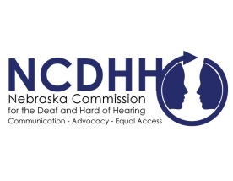
Pete Ricketts  Governor  Candice Arteaga,  Chairperson  Commission Members  Frances Beaurivage  Lincoln  Jonathan Scherling  Omaha  Jeremy Fitzpatrick  Omaha  Dr. Stacie Ray  Lincoln  Norman Weverka  Brainard  Robert Feit  Lincoln  Sandra Shaw  Seward  Diane Schutt  Fairbury  John C. Wyvill Executive Director | Vendors to Purchase Clear Face Masks  While we are almost a year into the global pandemic environment of COVID-19, it is without saying face masks will be around for quite some time. Communicating with individuals who are deaf are hard of hearing can be difficult with the traditional cloth face masks. When a face mask is covering a majority of the face, it creates a barrier for those who rely on critical facial cues or lip reading to communicate. There are many different option and styles of clear face masks that provide for effective communication. Please note NCDHH does not endorse or encourage one particular style or vendor. Please see the attached list of various venders available to purchase clear masks. These are vendors and businesses NCDHH has been made aware of, if you have another clear mask to add, please reach out to us at ncdhh@nebraska.gov.  #  To unsubscribe from the E-Communicator, reply to this email with “Unsubscribe from E-Communicator” in the subject line of the message.

