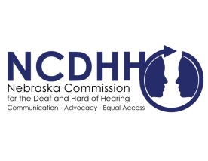
Pete Ricketts  Governor  Jeremy Fitzpatrick,  Chairperson  Commission Members  Frances Beaurivage  Lincoln  Jonathan Scherling  Omaha  Candice Arteaga  Greenwood  Dr. Stacie Ray  Lincoln  Norman Weverka  Brainard  Robert Feit  Lincoln  Sandra Shaw  Seward  Diane Schutt  Fairbury  John C. Wyvill Executive Director | Federal Government Warns of COVID-19 related Fraud & Scams  As the COVID-19 pandemic continues, there has been a new issue of warnings from the federal government. Recently, there have been numerous reports of scams to take advantage of individuals during this time, specifically related to stimulus payments and economic impact payments.  With the adjustment of many communicating remotely, scammers are using these means to steal personal information and money. These attempts may come through unsolicited emails, text messages or phone calls. Criminals or organizations send deceptive messages with aggressive tones or time sensitive issues in order to trick victims. Examples of these can range from demanding utilities, rent, mortgage or information related to stimulus checks. Scammers pose as physicians or government agencies such as the IRS, attempting to access personal information.  Those who receive unsolicited emails, text messages or social media attempts to gather information that appear to be from either the IRS or an organization closely linked to the IRS, such as the Electronic Federal Tax Payment System (EFTPS), should forward it to phishing@irs.gov. More information about possible scams and fraud may be found at https://www.irs.gov/newsroom/irs-issues-warning-about-coronavirus-related-scams-watch-out-for-schemes-tied-to-economic-impact-payments.  #  To unsubscribe from the E-Communicator, reply to this email with “Unsubscribe from E-Communicator” in the subject line of the message.

