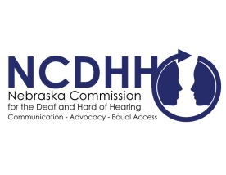
Pete Ricketts  Governor  Jeremy Fitzpatrick,  Chairperson  Commission Members  Frances Beaurivage  Lincoln  Jonathan Scherling  Omaha  Candice Arteaga  Greenwood  Dr. Stacie Ray  Lincoln  Norman Weverka  Brainard  Robert Feit  Lincoln  Sandra Shaw  Seward  Diane Schutt  Fairbury  John C. Wyvill Executive Director | Nebraska Department of Education Special Education Resources During COVID-19  Nebraska Commission for the Deaf and Hard of Hearing has worked with many agencies and organizations across Nebraska to ensure full access and services are provided to deaf and hard of hearing during the COVID-19 pandemic, including education.  Nebraska Department of Education Director for Special Education, Amy Rhone, has provided availability, information and resources for students and parents in Nebraska. Ms. Rhone recognizes the importance of students continuing their education remotely during this unique and changing time across the country.  A full list of resources and information for students with disabilities during COVID-19 can be found at: https://www.education.ne.gov/sped/.  You may also reach out with questions to NCDHH Education Advocate, Jessica Larrison, at jessica.larrison@nebraska.gov.  #  To unsubscribe from the E-Communicator, reply to this email with “Unsubscribe from E-Communicator” in the subject line of the message.

