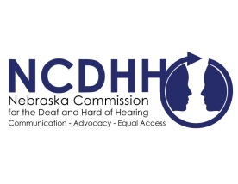 | 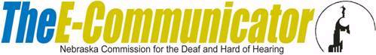
Pete Ricketts  Governor  Margie Propp,  Chairperson  Commission Members  Jeremy Fitzpatrick  Omaha  Regina Frerichs  Columbus  John Hogue,  Falls City  Dr. Carol Lomicky,  Kearney  Dr. Stacie Ray,  Lincoln  Norm Weverka,  Brainard  Dr. Frank Turk,  Omaha  Dr. Peter Seiler  Omaha  John C. Wyvill Executive Director | QAST Testing Updates  On June 17, 2016 the Nebraska Commission for the Deaf and Hard of Hearing (NCDHH) Full Board voted to increase the fee for the Mid-America Quality Assurance Screening Test (QAST). This, in large part, is to cover increased costs of proctoring the exam.  For the performance exam, the individual will still be given an option to choose between the transliterating or interpreter exam; or both. Each test will now cost $220.00, compared to previously $170.00. If an individual chooses to take both transliterating and interpreting performance exams, the cost will be $440.00.  For any questions please contact Interpreter Program Assistant, Crystal Pierce at 402-471-3581 or crystal.pierce@nebraska.gov.  Please click the link below to view.  The NCDHH newsletter, The Communicator, is now available online!  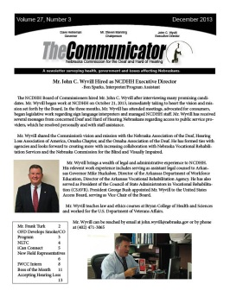  To unsubscribe from the E-Communicator, reply to this email with “Unsubscribe from E-Communicator” in the subject line of the message.

